- Introduction:
In this project, we are studying collision data provided by Seattle transportation. Due to the increase in collisions in the last couple of years it is a huge concern for the general public and the government. In order to control the rising numbers of collisions, it is utmost important to find the resolution for this.
  - Business Problem:
Few of the questions which will be answered in this project are as follows:
• Which section of the automobile should be focussed to improve safety in automobiles so that collision can be prevented? • What type of collisions are frequent and of what severity? • What and when the changes should be made in relation to infrastructure development?
• In what type of weather conditions maximum collisions have been recorded? • Were Speeding and weather variables contribute towards collision? • Which severity was at peak at different weather conditions? • What are the major reasons behind collision?
Target Audience and value created:
• Automobile companies: Automobile companies can use the results to identify opportunity to develop vehicle technology to prevent collisions • General Insurance companies: Insurance companies can modify its underwriting rules and make changes in product norms or make exclusions on the basis of data of maximum collisions • Traffic/Transportation ministry: Road Transport ministry can focus more on reasons of collision and importance of road maintenance
By doing this Companies and governments will be able to
• To increase their sales revenue by building a more sophisticated and top notch in safety product • By reducing risk and claims as much as possible and earn more profits • In order to show the better results to the general public by decreasing collision in no.s in coming years

About Data

Data Sources
We have data set from the Seattle Police department with a history of more than 15 years. In an
effort to reduce the frequency of car collisions in a community, an algorithm must be developed to predict the severity of an accident given the weather conditions, road and Junction type.
The data used for this study is provided by Coursera and can be found by clicking the following:
link: https://s3.us.cloud-object-storage.appdomain.cloud/cf-courses-data/CognitiveClass/DP0701EN/version-2/Data-Collisions.csv

Data Cleaning
Before cleaning dataset we had total rows: 194673 and Total Columns: 38.Few features were dropped off due to highly similar data or biased data points. Total rows: 194673 Total columns: 4.
Python and Jupyter notebook were used in performing the task.
Below are the data points which were dropped as they were highly correlated or biased:
- Whether or not collision was due to inattention
- Whether or not a driver involved was under the influence of drugs or alcohol
- Whether or not the pedestrian right of way was not granted
- Whether or not speeding was a factor in the collision
- Whether or not the collision involved hitting a parked car
Feature Selection
Features before the data cleaning process include SEVERITYCODE', 'X', 'Y', 'OBJECTID', 'INCKEY', 'COLDETKEY', 'REPORTNO', 'STATUS', 'ADDRTYPE', 'INTKEY', 'LOCATION', 'EXCEPTRSNCODE','EXCEPTRSNDESC', 'SEVERITYCODE.1', 'SEVERITYDESC', 'COLLISIONTYPE', 'PERSONCOUNT', 'PEDCOUNT', 'PEDCYLCOUNT', 'VEHCOUNT', 'INCDATE', 'INCDTTM', 'JUNCTIONTYPE', 'SDOT_COLCODE', 'SDOT_COLDESC', 'INATTENTIONIND', 'UNDERINFL', 'WEATHER', 'ROADCOND', 'LIGHTCOND', 'PEDROWNOTGRNT', 'SDOTCOLNUM', 'SPEEDING', 'ST_COLCODE', 'ST_COLDESC', 'SEGLANEKEY', 'CROSSWALKKEY', 'HITPARKEDCAR'
Like, involvement of parked cars were insignificant in collisions also the attribute "SPEEDING" can be considered not very consequential as no. of accidents due to speeding are neglible as compared with those without speeding.
After eliminating features where missing values are more than 60% and data is baised,we narrowed down to valuable features which are JUNCTIONTYPE','WEATHER','ROADCOND','SEVERITYCODE'

Methodology
2.1 Exploratory Data Analysis:

For finding out the impact of each attribute,
Independent Variables:
- Weather Conditions: A description of the weather conditions during the time of the collision
- Road: The condition of the road during the collision
- Junction Type: Category of junction at which collision took place
Target/Independent Variable:
- Severity Code: A code that corresponds to the severity of the collision:
- 3- Fatality the number of fatalities in the collision. This is entered by the state.
- 2b- serious injury The number of serious injuries in the collision
- 2- Injury The number of total injuries in the collision.
- 1- property damage
- 0- unknown
A model will be created that can predict severity based on independent variables.

In this project in order to analyse data for the factors which can impact accident rate we will find out which attribute is significant in contribution of various collisions. I will limit the analysis to certain highly contributing factors only.
In first step we have collected the required data. In addition to this, we have identified that Junction Type, Weather and Road Conditions are the major contributors in collisions. Lots of Exploratory data analysis has been involved in this case.
Second step involved finding correlation between independent variables and dependent variables individually and the results of the same has been shown with plots. Majorly bar chart has been used to show the correlation. Attributes with better correlation were focussed at subsequent steps later on.
In third and final step machine learning model will be made that can predict the severity of collision in the future. Different ML Models will be compared with each other. As the data type is categorical, classification method is used to make a ML model. Data was split into train set and test set for this purpose. Also categorical data was converted into numerical data as ML Models does not work with categories. Different classification ML Models Compared are: Decision tree, KNN, Logistic Regression, Support Vector Machine. The output will be presented and be used by stakeholders to avoid collisions.

Relationship between Junction Type Vs Collisions

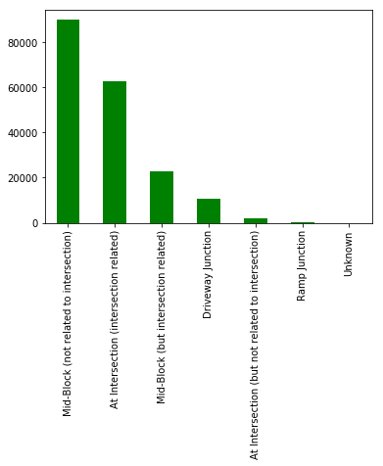

It can be seen that collisions are more in numbers when junction types are mid-block which are not related to intersection) and at intersection.

Relationship between Road Conditions and Collisions
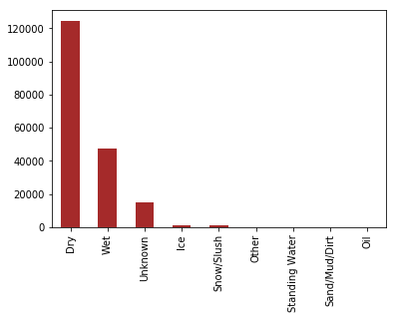
What and when the changes should be made in relation to infrastructure development?
Ostensibly accidents are more severe when road conditions are dry followed by when it is wet.

Relationship between Severity and Collisions:
What type of collisions are frequent and of what severity?
Severities are of two types:
- Property Damage only collision
- Collision which includes injury too

In majority of the collisions, property is getting damaged while injury is relatively lesser.
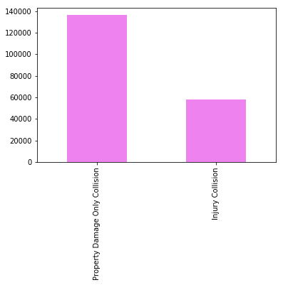

Relationship between Road Condition, Severity and Collisions
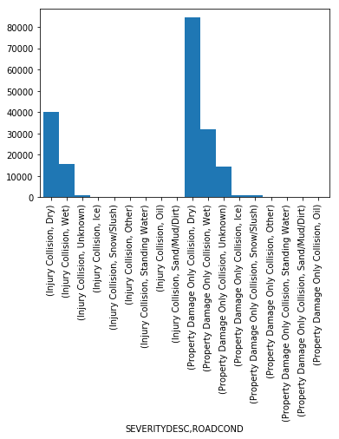
- It can be observed that collisions where property was damaged are most when the road conditions were dry in comparison to when they were in wet conditions
- Likewise, collisions involving injury and threat to life are most when road condition is dry

Analysis of Collision Types:
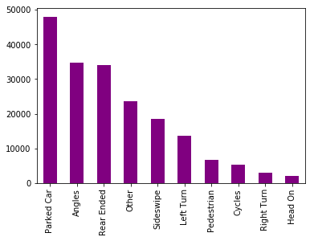

Here, Parked Cars are most collided followed by collision at angles and rear end.

Relationship between Weather, Severity and Collisions
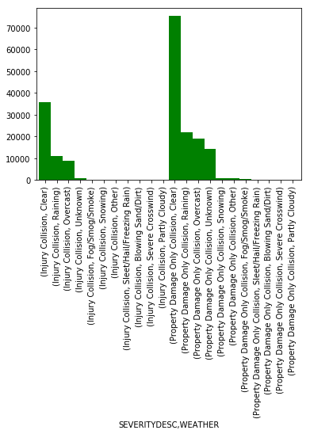
It can be seen that collisions where only property damage is involved is most when weather is clear similar to when collisions also include injury collision.

Relationship between Severity description, junction type and collisions

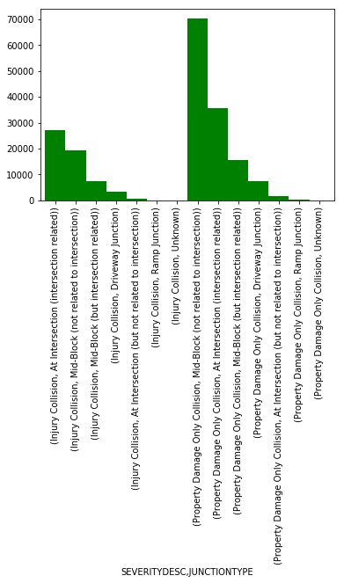
This figure conveys that most collisions involving only property damage are at road’s mid-block or at intersection when compared to those collisions which include injury as well.

- Predictive Modelling:
After executing machine learning algorithms using various models like Logistic Regression, Decision Tree, SVM, and KNN we got the following results:
Jaccard index: 0.70
F1-score: 0.58
Log Loss: 0.59
Accuracy: 60.43%
KNN Model:
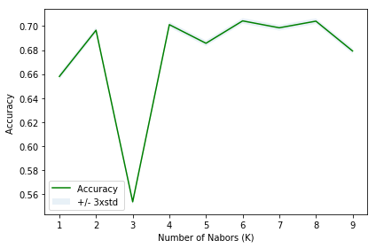
The best accuracy with KNN model is with 70.43% when k= 6

- Results:
- 70% of the collisions involve only property damage
- 44% of the collisions where only property was damaged took place when road condition was dry whereas 22% of the total collisions where road condition involve severe injury and threat to life
- 35% of the total collisions involve majorly property damage and 27% of the total collisions include major injury as well and all this is when weather is clear
- 45% of the total collisions are at mid block (not related to intersection) whereas 35% of the total collisions are at intersection
- 25% of the total accidents happened with parked cars whereas 30% of the total collisions are either at angles or at rear ends
- Discussion
- Property damage is most in all the collisions
- Collisions are more in clear weather in comparison to when it is raining or overcast. This shows that people are more alert when they feel prone to accident due to bad weather
- Vehicles are collided on the higher side at angles and rear ends followed by parked cars collision
- Conclusion
In this study, we have found various factors for the collision and how much each factor is significant. These results can be substantial for the target audience as follows:
- Automobile companies can use the results to identify opportunity to develop vehicle technology to prevent collisions
- Insurance companies can modify its underwriting rules and make changes in product norms or make exclusions on the basis of data of maximum collisions
- Road Transport ministry can focus more on reasons of collision and importance of road maintenance
By doing this, Companies and governments will be able to:

• To increase their sales revenue by building a more sophisticated and top notch in safety product
• By reducing risk and claims as much as possible and earn more profits
• In order to show the better results to the general public by decreasing collision in no.s in coming years

